Assignment 3-5 Using a WHILE loop

Brewbean's wants to include a feature in their application that calculates the total number (quantity) of a specified item that can be purchased with a given amount of money. Create a block using a WHILE loop to increment the cost of the item until the dollar value is met. Test first with a total spending amount of $100 and product id 4. Then test with an amount and product of your choice. Use host variables to provide the total spending amount and product id to the block.

|  |
| --- |
| DECLARE  lv_total_spent NUMBER := 100; -- Host variable for total spending amount  lv_product_id NUMBER := 4; -- Host variable for the product ID  lv_price NUMBER; -- Variable to store the price of the selected product  lv_items_purchased NUMBER := 0; -- Counter for the number of items that can be bought  BEGIN  -- Fetch the price of the product using the provided product_id  SELECT price INTO lv_price  FROM bb_product  WHERE idproduct = lv_product_id;    -- Ensure we found the product and have a valid price  IF lv_price IS NULL THEN  DBMS_OUTPUT.PUT_LINE('Product not found');  RETURN;  END IF;    -- Use a WHILE loop to calculate how many items can be bought  WHILE lv_total_spent >= lv_price LOOP  lv_total_spent := lv_total_spent - lv_price; -- Deduct the price of one item from total_spent  lv_items_purchased := lv_items_purchased + 1; -- Increment the item count  END LOOP;    -- Output the result  DBMS_OUTPUT.PUT_LINE('Items that can be purchased: ' || lv_items_purchased);  DBMS_OUTPUT.PUT_LINE('Remaining money: $' || lv_total_spent);    END; |

Changing the amount to 500 and product is to 6

Assignment 3-6 Working with IF statements

Brewbean's calculates shipping cost based on the quantity of items in an order. Assume the quantity column in the bb_basket table contains the total number of items in a basket. A block is needed to check the quantity provided by a host variable and determine the shipping cost. Display the determined shipping cost on the screen. Test using the basket ids of 5 and 12. Apply the shipping rates as listed in Table 3-3.

|  |  |
| --- | --- |
| Quantity of Items | Shipping Cost |
| Up to 3 | $5.00 |
| 4-6 | $7.50 |
| 7-10 | $10.00 |
| Over 10 | $12.00 |

|  |
| --- |
| DECLARE  lv_basket_id NUMBER := 5; -- Host variable for basket_id, change for testing with other basket IDs (e.g., 12)  lv_quantity NUMBER; -- Variable to store the quantity of items in the basket  lv_shipping_cost NUMBER; -- Variable to store the calculated shipping cost  BEGIN  -- Retrieve the quantity of items in the basket using the basket_id  SELECT quantity INTO lv_quantity  FROM bb_basket  WHERE idbasket = lv_basket_id;    -- Check if quantity is found  IF lv_quantity IS NULL THEN  DBMS_OUTPUT.PUT_LINE('Basket not found');  RETURN;  END IF;    -- Determine the shipping cost based on the quantity using IF-ELSE or CASE statement  IF lv_quantity <= 3 THEN  lv_shipping_cost := 5.00;  ELSIF lv_quantity BETWEEN 4 AND 6 THEN  lv_shipping_cost := 7.50;  ELSIF lv_quantity BETWEEN 7 AND 10 THEN  lv_shipping_cost := 10.00;  ELSE  lv_shipping_cost := 12.00;  END IF;    -- Display the shipping cost  DBMS_OUTPUT.PUT_LINE('Basket ID: ' || lv_basket_id);  DBMS_OUTPUT.PUT_LINE('Quantity of items: ' || lv_quantity);  DBMS_OUTPUT.PUT_LINE('Calculated shipping cost: $' || lv_shipping_cost);    END; |

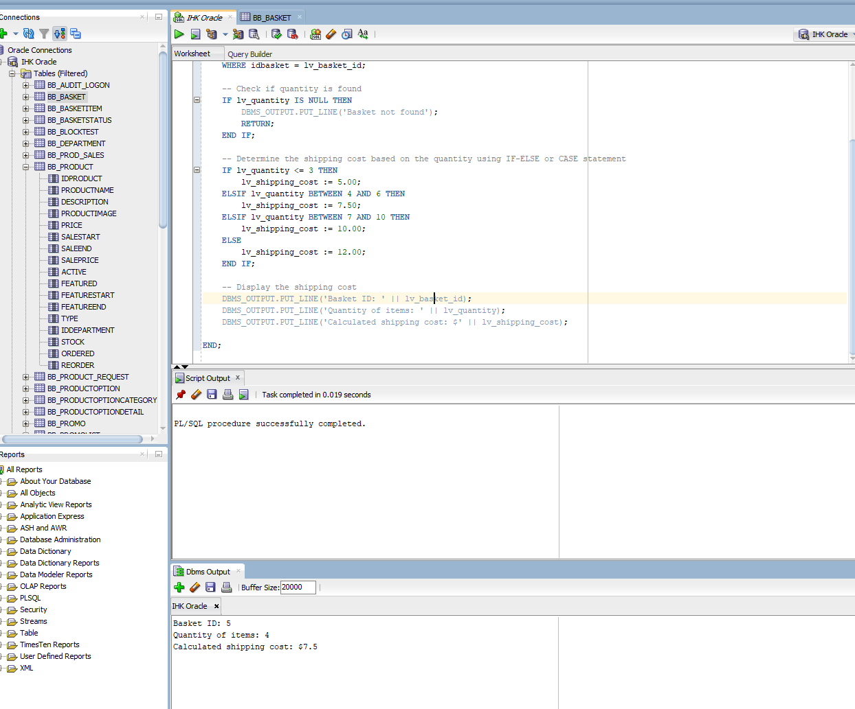

When basket id = 12

Assignment 3-7 Using scalar variables for data retrieval

The Brewbean's application contains a screen that displays order summary information, including IDBASKET, SUBTOTAL, SHIPPING, TAX, and TOTAL columns from the BB_BASKET table. Create a PL/SQL block that will use scalar variables to retrieve this data and then display it on the screen. A host variable should provide the IDBASKET value. Test the block using IDBASKET 12.

|  |
| --- |
| DECLARE  -- Host variable for the basket ID  lv_basket_id NUMBER := 12;    -- Scalar variables to store retrieved values  lv_subtotal NUMBER;  lv_shipping NUMBER;  lv_tax NUMBER;  lv_total NUMBER;  BEGIN  -- Retrieve the order summary data using the provided basket_id  SELECT subtotal, shipping,tax, total  INTO lv_subtotal,lv_shipping,lv_tax,lv_total  FROM bb_basket  WHERE idbasket = lv_basket_id;    -- Output the order summary information  DBMS_OUTPUT.PUT_LINE('Order Summary for Basket ID: ' || lv_basket_id);  DBMS_OUTPUT.PUT_LINE('-----------------------------------');  DBMS_OUTPUT.PUT_LINE('Subtotal: $' || TO_CHAR(lv_subtotal, '999.99'));  DBMS_OUTPUT.PUT_LINE('Shipping: $' || TO_CHAR(lv_shipping, '999.99'));  DBMS_OUTPUT.PUT_LINE('Tax: $' || TO_CHAR(lv_tax, '999.99'));  DBMS_OUTPUT.PUT_LINE('Total: $' || TO_CHAR(lv_total, '999.99'));    END; |

Assignment 3-8 Using a record variable for data retrieval

The Brewbean's application contains a screen that displays order summary information, including IDBASKET, SUBTOTAL, SHIPPING, TAX, and TOTAL columns from the BB_BASKET table. Create a PL/SQL block that will use a record variable to retrieve this data and display it on the screen. A host variable should provide the IDBASKET value. Test the block using IDBASKET 12.

|  |
| --- |
| DECLARE  -- Host variable for the basket ID  lv_basket_id NUMBER := 12; -- Change this for testing with different basket IDs  -- Record type to store the basket data (IDBASKET, SUBTOTAL, SHIPPING, TAX, TOTAL)  TYPE basket_record IS RECORD (  lv_idbasket NUMBER,  lv_subtotal NUMBER,  lv_shipping NUMBER,  lv_tax NUMBER,  lv_total NUMBER  );  -- Record variable to hold the data for the basket  basket_info basket_record;  BEGIN  -- Retrieve the order summary data using the provided basket_id  SELECT idbasket, subtotal, shipping, tax, total  INTO basket_info.lv_idbasket, basket_info.lv_subtotal, basket_info.lv_shipping, basket_info.lv_tax, basket_info.lv_total  FROM bb_basket  WHERE idbasket = lv_basket_id;  -- Output the order summary information  DBMS_OUTPUT.PUT_LINE('Order Summary for Basket ID: ' || basket_info.lv_idbasket);  DBMS_OUTPUT.PUT_LINE('-----------------------------------');  DBMS_OUTPUT.PUT_LINE('Subtotal: $' || TO_CHAR(basket_info.lv_subtotal, '999.99'));  DBMS_OUTPUT.PUT_LINE('Shipping: $' || TO_CHAR(basket_info.lv_shipping, '999.99'));  DBMS_OUTPUT.PUT_LINE('Tax: $' || TO_CHAR(basket_info.lv_tax, '999.99'));  DBMS_OUTPUT.PUT_LINE('Total: $' || TO_CHAR(basket_info.lv_total, '999.99'));  END; |